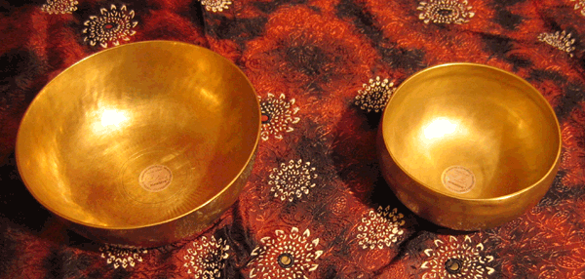
- IN HARMONY WITH THE INNER SILENCE -
SOUND TREATEMENT WITH TIBETIAN SINGING BOWLS

Into wonderful ambiente of silence and bliss we open a wonderful space to balance out the body and the entire chakra system. During the session the body and soul enjoys a complete regeneration through vibratiang healing waves – this frequencies are vitalising and calming the whole nervsystem and activates the energetic parts of the meridian system

Overtones in higher and lower tones recreate a complete balance of the organs, senses and electromagnetic waves of the brain and bodysystem. Also the frequencies are activating the chakras to open the radiating light

The soundhealing with tibetian bowls can be used in combination with an active meridian massage or herbal treatment (Juniper, lavender, rose, etc.)
Basic we use coconut oil and mix it with different herbs for the clients well being

Dollar 70.- / soundbath with Meridian Massage / coconut oil / 1.5 hours

Dollar 40 / soundbath just with tibetian singing bowls / 40 minutes

Aladin Phone: +506 (0) 64490080 Mail: twister-alan@gmx.ch

BELOVED WELL - COME

