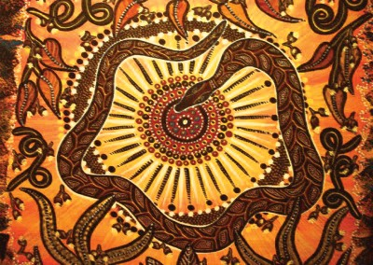
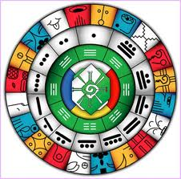
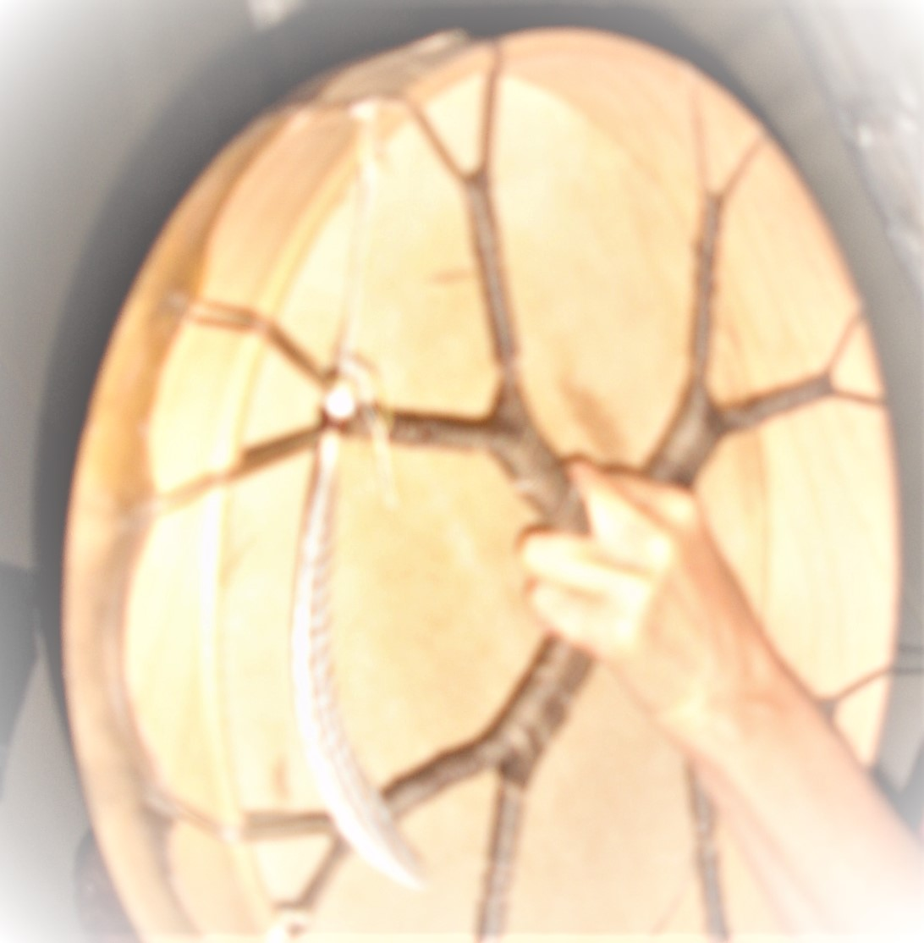
SHAMANIC SESSIONS

AURA CLEANING WITH HOLY INCENSES / ENERGETIC RELEASE / SACRED TABACCO / RAPÉ

EMPOWERMENT WITH SACRED DRUMS AND DIDGERIDOO / SINGING

READINGS WITH ASTROLOGIC SIGNS AND MAYA ORACLE / RELEASES WITH ARCHETYPIC FAMILY CONSTELLATION

Into wonderful ambiente of silence and bliss we open a wonderful space to clean and empower the whole body and energetic system for the given moments. During 1.5 until 2.5 hours the body and soul enjoys a complete regeneration through the vibratiang healing waves of the sacred shamanic drum and the didgeridoo and aura claning treatement with sacred herbs and incenses. The optional archetypic readings show up a deep understanding and clearity to important Life issues and karmic themes

The aura cleaning is a special way from the indigenous shamanic healers to release all energy around your body and the energetic system. Into the deep process you will find moments of self release and deep peace – through the clear view of the healer you will become also informations and tools how to regenerate your body and soul for deeper moments in Life of bliss and joy

The sacred drum / didgeridoo session helps the client to unlock inner portals and liberates mental (blocked) waves. The use of essential oils or sacred tabacco (smoke or rapé) are cleaning very efficient the whole energy system. Sacred chants with the drum and the waves of the didgeridoo activate the whole nerv and meridian system. An empowerment will show up of all your higher senses within the inner strength and intention

Since thousands of years, the vibrating sound of the didgeridoo and the rhythm of the drum are used in very specific ways of healing in regenerating the life energy. In shamanic sience we re-activate also the connection between this world and the higher worlds, the world of our pure soul and the source of all being

Dollar 70.- shamanic treatement / 1.5 hours
Dollar 120.- shamanic treatement + astrologic analysis & maya oracle / 2.5 hours

Aladin – phone: +506 (0) 64490080 / Mail: twister-alan@gmx.ch

BELOVED WELL - COME

