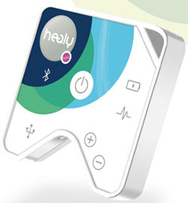
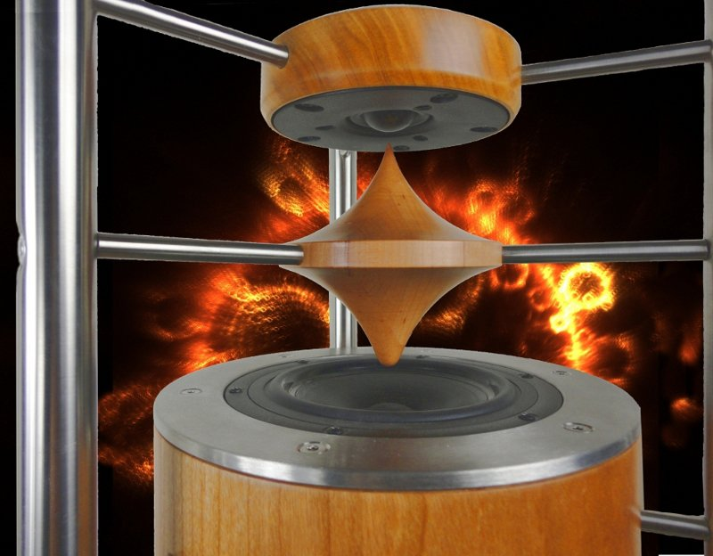
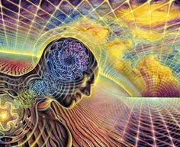

- HEALY WORLD FREQUENCE THERAPY -
SOUND BATH WITH THE ETERNITA SOUNDSYSTEM

Into wonderful ambiente of silence and bliss we open a wonderful space to balance out the body, mind and soul. In the treatements we let the healing waves radiate on specific bodyparts, nervsystem, organs etc. - as well the entire energetic system wich is needet to get healed or supported. During the session the body and soul enjoys a complete regeneration through vibrating healing waves from the HEALY freqency generator – this frequencies are vitalising all kind of desired parts needet to support for health and wellbeing. Into first consultation will find out together wich part is most important to support – mental waves, meridians, chakras, psychical parts etc.

Each program is exactly programmed in form of the absolut optimum Hz frequencyes from profound studyes in laboratoryes of scientists and doctors for each level of treatement. The electro-magnetic waves balance out all necessary levels of the whole physical or energetic body. In higher and lower frequencyes the healing waves recreate a complete balance of all senses. The treatements are also activating the meridians and chakras to open the radiating cosmic light

During the sessions with the HEALY frequency generator, we let soft meditative music play with the high sound quality ETERNITA system. The treatement will be supported in combination with herbal sensual therapy in form of pure essential or aetheric oils (Jasmin, lavender, rose, etc.)

Dollar 70.- / consultation / soundbath + frequence therapy / 1.5 hours
- this therapy allowes one specific treatement – as example : nerve meridian

in general a single treatement is during ca. 1 hour. Each extra theme of regeneration costs
30 Dollar extra. In many cases it is proposed to combine different types of frequency treatements. Will find out together in a first consultation

Aladin Phone: +506 (0) 64490080 Mail: twister-alan@gmx.ch

BELOVED WELL - COME

